PROTECTIONS TESTS.

1. OVP (Over Voltage Protection).

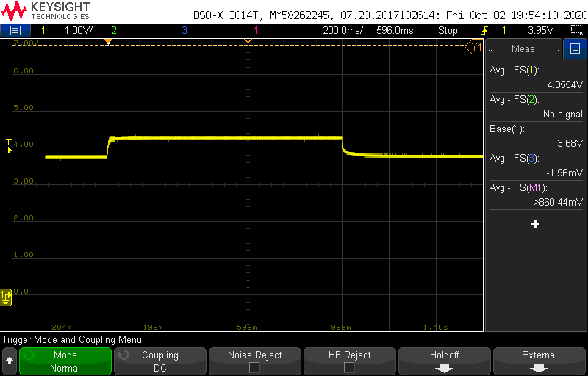Has we can see in the image, when the battery level pass the OVP voltaje (4,28 in this case) during the OVP time (1s), the protection Circuit (PC) open the transistors.

This protection is not bloking, the battery Will return to its normal state after the charger its removed.

We consider it a blocking protection when in spite of havinf removed the cause of the protection trigger, the battery not recover. In this case, its neccesary disconnect the battery and the PC from the rest of the system.

1. OCD (Over Current Discharge).

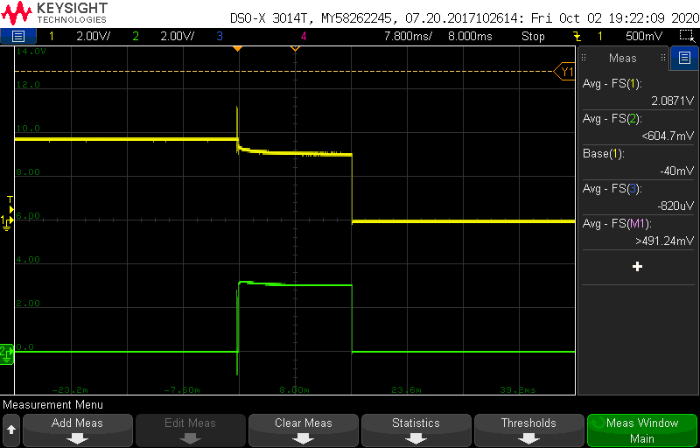The OCD protection, check the aomunt of current its discharging and when its pass the limit (7 A in this case; take account the the green signal its the voltaje across a 0,5 R) during the OCD time (16 ms), the PC open the transistor.

This protection is not bloking, the battery Will return to its normal state after the load its removed.

1. 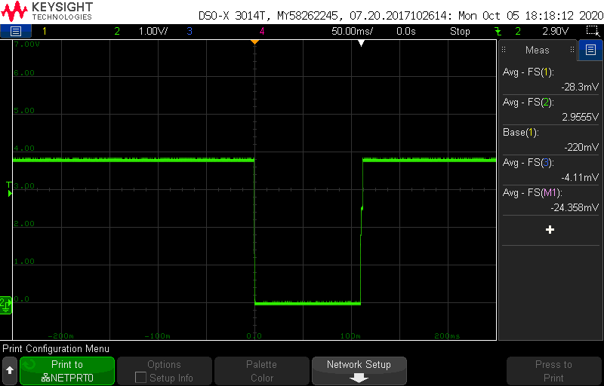SCD (Shor Circuit Discharge).

After short circuit the output, and the prottection trigger, when the SC its removed, the output recover intstantly the normal state.